What are your goals in three months?

I Johny Driotis, speak English in simple present and present progressive I use more vocabulary, not forget the future use the going to and will.

**Simple present**

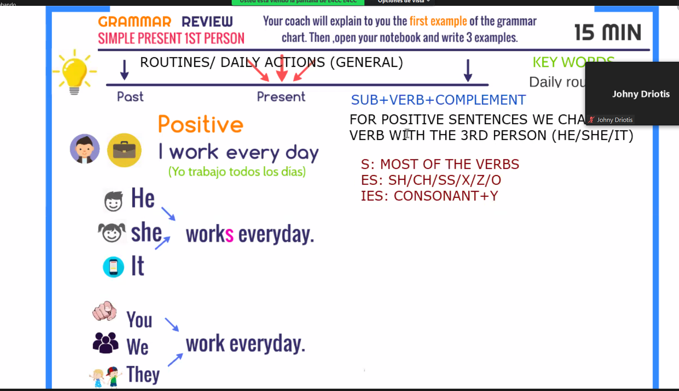

I don’t bad habits but I have not enough exercise

Sometimes I like sleep on afternoon, but I wake up early

I usually play videogames after arrive from job.

I like study on night, but I have

It class begin at 6 pm

My routine is tired then

I wake up at 6:00 am,

Later Then I brush my teeth

Take a shower at 7;00 am

To continue I have breakfast and I drive my vehicle at my work

I work between 8;00 and 6;00 pm.

Investigar sobre el **simple present**

**Exposition para el siguiente sábado**

**Recordar que it puede sustituir lugares, casas, object**

**What do you wake up everydays**